Business Question and Visualization Report

Team ID | MCA
Project Name | Heart Disease Risk and Patient Health Analysis
Maximum Marks | 5 Marks

Visualization development refers to the process of creating graphical representations of data to facilitate understanding, analysis, and decision-making. The goal is to transform complex datasets into visual formats that are easy to interpret, enabling users to gain insights and make informed decisions. Visualization development involves selecting appropriate visual elements, designing layouts, and using interactive features to enhance the user experience. This process is commonly associated with data visualization tools and platforms, and it plays a crucial role in business intelligence, analytics, and reporting
Business Questions and Visualisation
Heart Disease Risk and Patient Health Analysis – Power BI
- How does heart disease prevalence vary by smoking status?
Visualization: Stacked Bar Chart
Dashboard: Heart Disease Risk and Patient Health Analysis
Purpose: To compare heart disease categories across never, former, and current smokers.
Screenshot of Visualisation:
Use the "Heart Disease Prevalence by smoker status" chart from your first dashboard

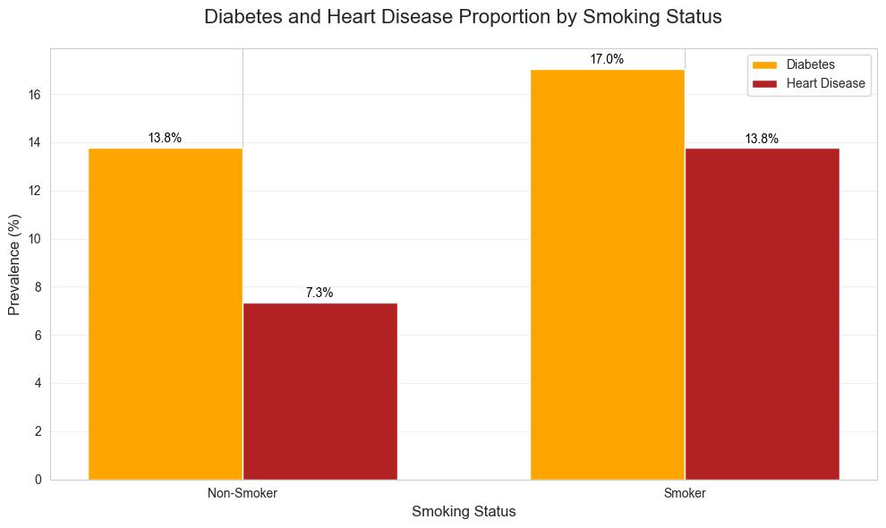

- What is the distribution of patients based on family history of heart disease?
Visualization: Pie Chart
Dashboard: Heart Disease Risk and Patient Health Analysis
Purpose: To understand the proportion of patients with and without a recorded family history of heart disease.
Screenshot of Visualisation:
Use the "Patient Distribution by family history of heart disease" pie chart.

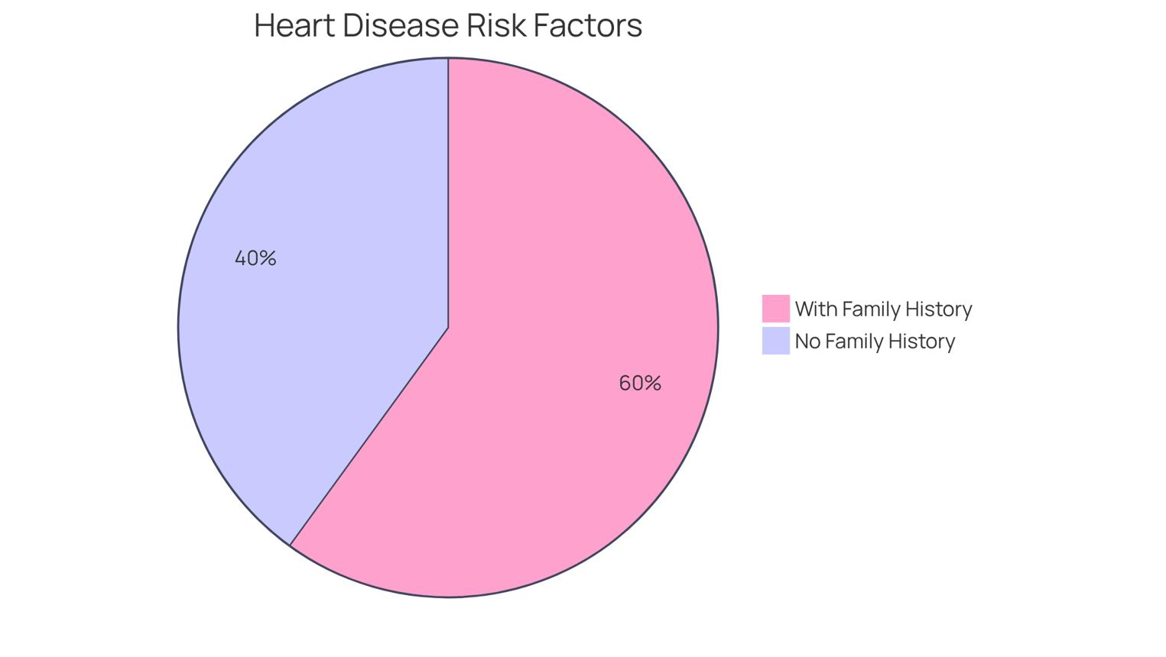

- How does chest pain type vary across smoking groups?

Visualization: Clustered Bar Chart
Dashboard: Patient Wellness & Heart Health Analytics
Purpose: To compare the distribution of chest pain types among current, former, and never smokers

Screenshot of Visualisation:
Use the "Chest Pain Patterns Across Smoking Groups" chart.

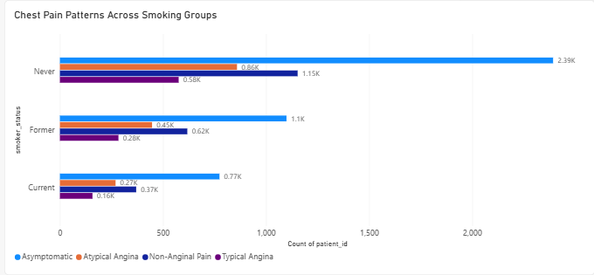

- What is the average stress level across different smoking statuses?
Visualization: Horizontal Bar Chart
Dashboard: Heart Disease Risk and Patient Health Analysis
Purpose: To compare average stress-related scores across smoking groups.
Screenshot of Visualisation:
Use the "Average of st_depression by smoker_status" bar chart.
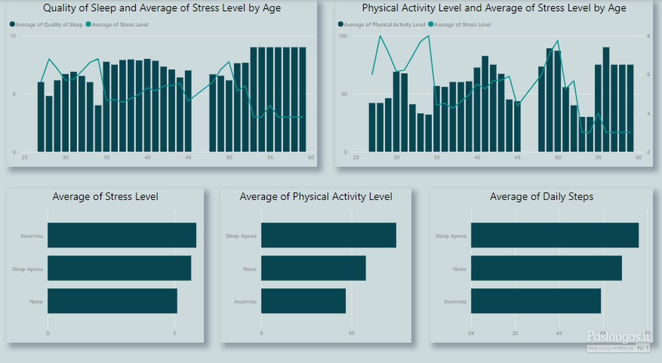
5. How does BMI vary with resting heart rate?
Visualization: Line Chart
Dashboard: Cardiovascular Health & Risk Insights
Purpose: To visualize the variation in average BMI across different resting heart rate ranges.
Screenshot of Visualisation:
Use the "BMI Variation by Resting Heart Rate" line chart.
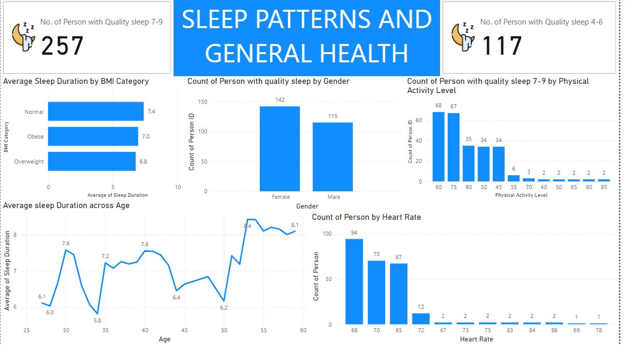
- What percentage of patients experience exercise-induced angina?
Visualization: Pie Chart
Dashboard: Cardiovascular Health & Risk Insights
Purpose: To show the distribution of patients with and without exercise-induced angina in the dataset
Screenshot of Visualisation:
Use the "Exercise-Induced Angina Prevalence" pie chart.
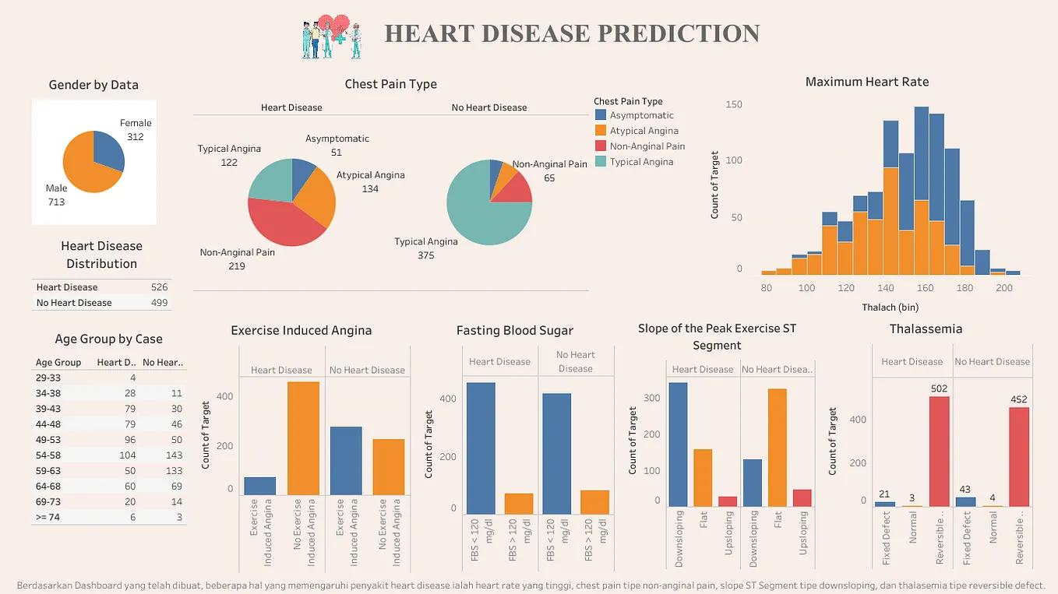

7. How is chest pain distributed among different smoking statuses?
Visualization: Clustered Bar Chart
Dashboard: Cardiovascular Health & Risk Insights
Purpose: To compare patient counts for different chest pain types across smoking statuses.
Screenshot of Visualisation:
Use the "Chest Pain Distribution by Smoking Status" bar chart.
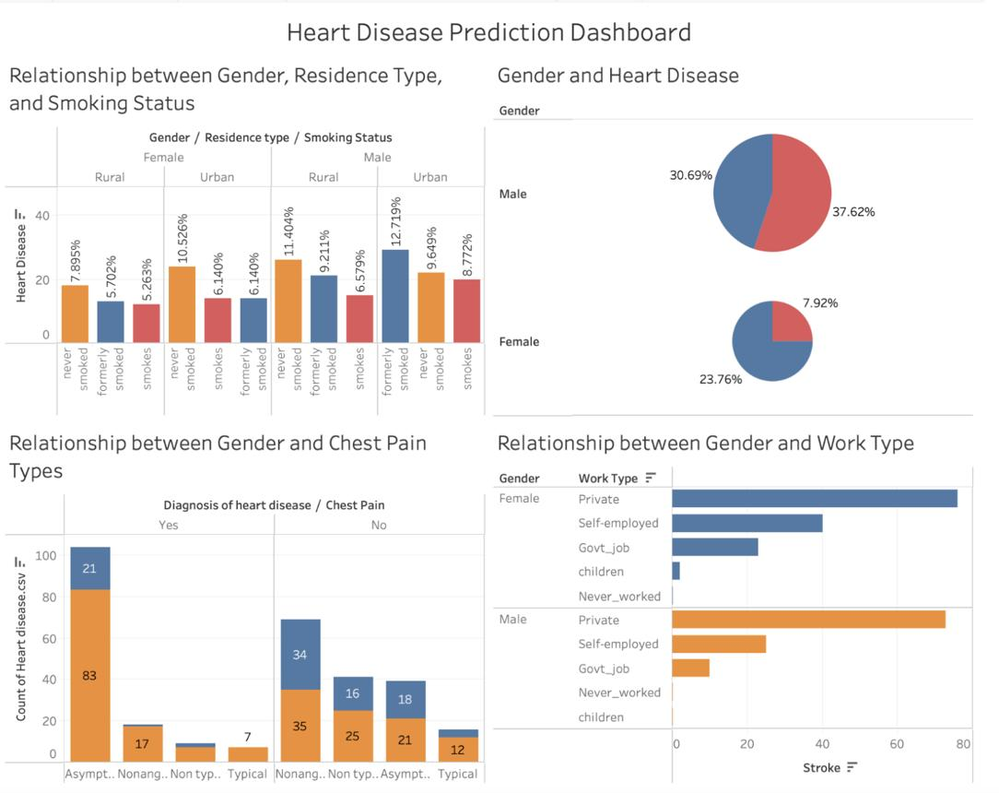
8.How does wearable technology adoption vary among patients?
Visualization: Donut Chart
Dashboard: Patient Wellness & Heart Health Analytics
Purpose: To visualize the proportion of patients using or not using wearable technology, based on the dataset.
Screenshot of Visualisation:
Use the "Wearable Technology Adoption Among Patients" donut chart.
